22nd Sunday after Pentecost
CHRIST LUTHERAN CHURCH | Lodi, California
October 29, 2023

WELCOME TO WORSHIP
Welcome to Christ Lutheran Church. We pray that your soul will be strengthened by the good news about God’s grace, love, and forgiveness given to us. If you would like to learn more about our church, please speak with our pastor or one of our members after the service.
- Bathrooms are located in the fellowship hall. A changing table is located in the women’s bathroom.
WORSHIP THEME
Christians are called to rise above the squabbles of the world and trust in the God who moves all things for our good. That powerfully influences the way that we live our lives: the way we spend our money; the attitude we have about our government; the debates with which we choose to engage; and the worries that occupy our hearts. May Jesus’ words today lead us to trust in him all the more.

The Service of the Word
We gather as a congregation to hear God’s Word proclaimed and respond with prayer, praise, and thanksgiving.

OPENING HYMN Blessed Jesus, At Your Word | CW 919
Please stand for the final verse of the hymn

The Service, Setting one Hymnal page 154

PRAYER OF THE DAY
M: The Lord be with you.
C: And also with you.
M: Let us pray.
Lord, keep your household, the Church, in continual godliness and set us free from all adversities that, under your protection, we may serve you with true devotion and holy deeds; through Jesus Christ, your Son, our Lord, who lives and reigns with you and the Holy Spirit, one God, now and forever.
C: Amen
FIRST LESSON Isaiah 45:1–7
The Lord called Cyrus his anointed, even though Cyrus was a pagan king who did not believe in the Lord. God can use the kingdoms of the world to accomplish his gracious purpose.
45 “This is what the Lord says to his anointed,
to Cyrus, whose right hand I take hold of
to subdue nations before him
and to strip kings of their armor,
to open doors before him
so that gates will not be shut:
² I will go before you
and will level the mountains;
I will break down gates of bronze
and cut through bars of iron.
³ I will give you hidden treasures,
riches stored in secret places,
so that you may know that I am the Lord,
the God of Israel, who summons you by name.
⁴ For the sake of Jacob my servant,
of Israel my chosen,
I summon you by name
and bestow on you a title of honor,
though you do not acknowledge me.
⁵ I am the Lord, and there is no other;
apart from me there is no God.

I will strengthen you,
though you have not acknowledged me,
⁶ so that from the rising of the sun
to the place of its setting
people may know there is none besides me.
I am the Lord, and there is no other.
⁷ I form the light and create darkness,
I bring prosperity and create disaster;
I, the Lord, do all these things.
M: The Word of the Lord.
C: Thanks be to God.
PSALM Psalm 96, CW ‘21
SECOND LESSON 2 Corinthians 9:6–11
Paul encourages generous giving out of a grateful heart. As we give our gifts to God and his representatives, we do so no with grumbling, but with joy.
⁶ Remember this: Whoever sows sparingly will also reap sparingly, and whoever sows generously will also reap generously. ⁷ Each of you should give what you have decided in your heart to give, not reluctantly or under compulsion, for God loves a cheerful giver. ⁸ And God is able to bless you abundantly, so that in all things at all times, having all that you need, you will abound in every good work. ⁹ As it is written:
“They have freely scattered their gifts to the poor;
their righteousness endures forever.”
¹⁰ Now he who supplies seed to the sower and bread for food will also supply and increase your store of seed and will enlarge the harvest of your righteousness. ¹¹ You will be enriched in every way so that you can be generous on every occasion, and through us your generosity will result in thanksgiving to God.
M: The Word of the Lord.
C: Thanks be to God.

GOSPEL ACCLAMATION
Alleluia. O Lord, your words are my joy and my heart’s delight. Alleluia.
THE GOSPEL Matthew 22:15–21
Jesus refuses to be trapped in his words by those who want to engage in pointless debates. He calls his listeners to a godly allegiance to the kingdom of heaven.
¹⁵ Then the Pharisees went out and laid plans to trap him in his words. ¹⁶ They sent their disciples to him along with the Herodians. “Teacher,” they said, “we know that you are a man of integrity and that you teach the way of God in accordance with the truth. You aren’t swayed by others, because you pay no attention to who they are. ¹⁷ Tell us then, what is your opinion? Is it right to pay the imperial tax to Caesar or not?”
¹⁸ But Jesus, knowing their evil intent, said, “You hypocrites, why are you trying to trap me? ¹⁹ Show me the coin used for paying the tax.” They brought him a denarius, ²⁰ and he asked them, “Whose image is this? And whose inscription?”
²¹ “Caesar’s,” they replied.
Then he said to them, “So give back to Caesar what is Caesar’s, and to God what is God’s.”

M: This is the Gospel of the Lord.
C: Praise be to you, O Christ!
HYMN OF THE DAY All Depends on Our Possessing| CW 807
SERMON Matthew 22

NICENE CREED Page 162
OFFERING
In response to God’s love and forgiveness, we give back a portion of what he has given us. The members of Christ Lutheran Church have joined to proclaim the gospel to this community. These offerings support that work. While our guests are welcome to participate, they should not feel obligated to do so.

PRAYER OF THE CHURCH Page 164

THE SACRAMENT Page 165
CLOSING HYMN Take the World, But Give Me Jesus | CW 699

COPYRIGHT INFORMATION
Content requiring a copyright license is reproduced under OneLicense.net #A-718312. All rights reserved. The Common Service: Texts revised from The Lutheran Hymnal, 1941. Music revised by James Engel. Scripture Quotations: From the Holy Bible, New International Version (NIV 1984), © 1973, 1978, 1984 by Biblica, Inc.

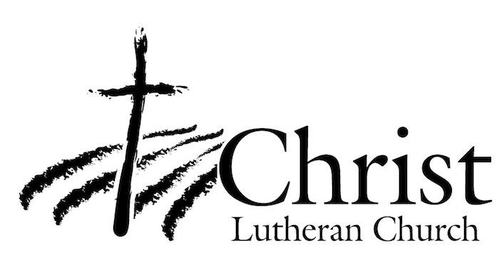
13009 N. Elderberry Ct.
Lodi, CA 95242
www.christlodi.org
209-368-6250
Pastor Tim Leistekow
WELCOME TO CHRIST EV. LUTHERAN CHURCH!
We preach a message of forgiveness, hope and peace
through the death and resurrection of Jesus Christ.
Families and individuals of all ages will find opportunities
both to grow and to serve.
Our mission statement:
Look what Christ is doing!
He binds us together in fellowship
He gathers us in for worship
He builds us up for service
He sends us out with the gospel

“Now you are the body of Christ,
and each one of you is a part of it.”
(1 Corinthians 12:27)

